Name: Viernes, Michael E. Grade & Section: MAWD 401 Date: 4/7/2021

**Steps**

1. Showing creation of tables and data within.

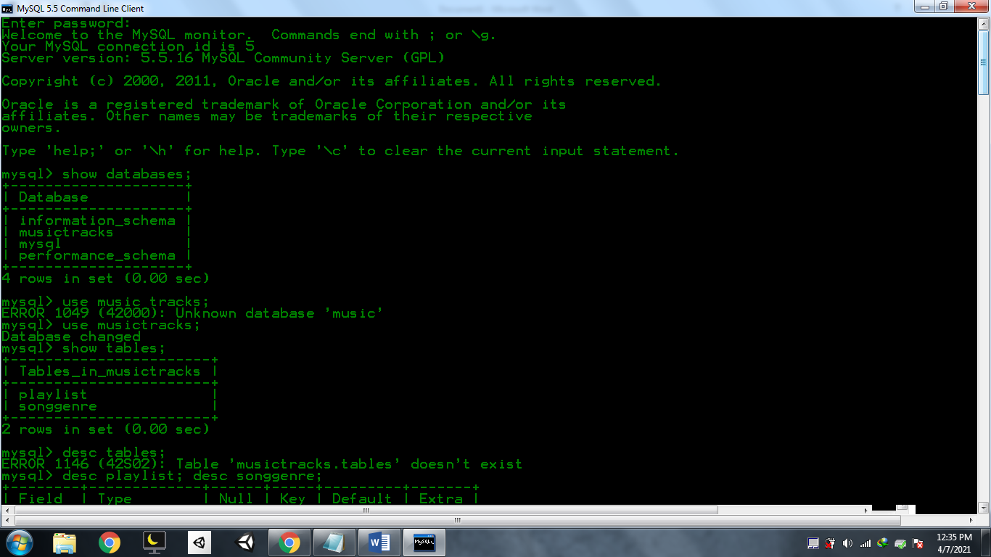

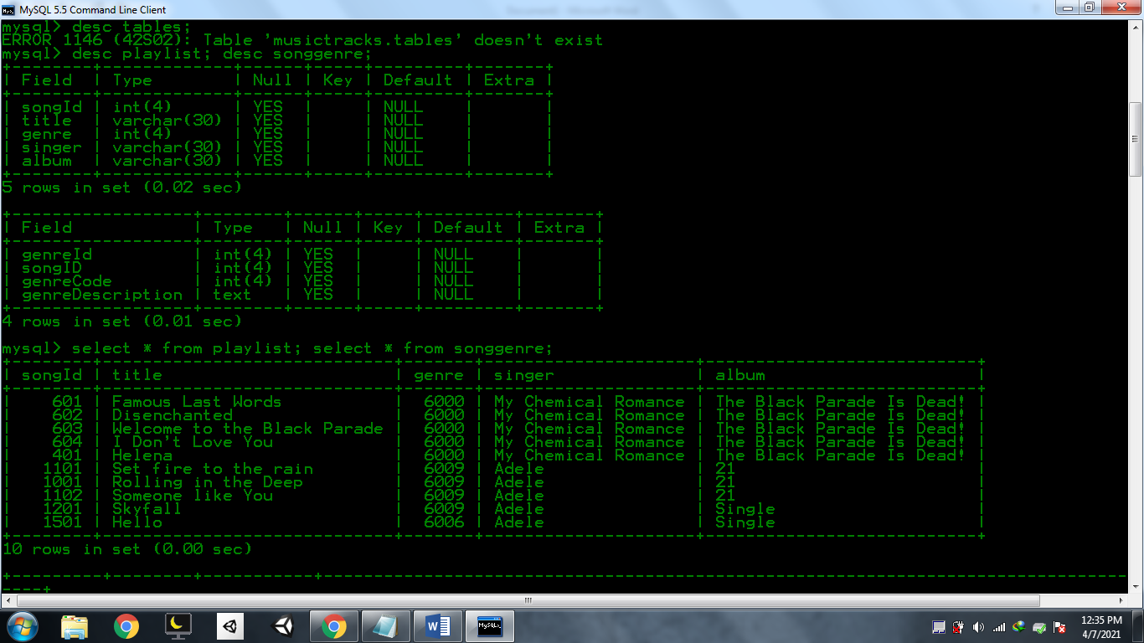

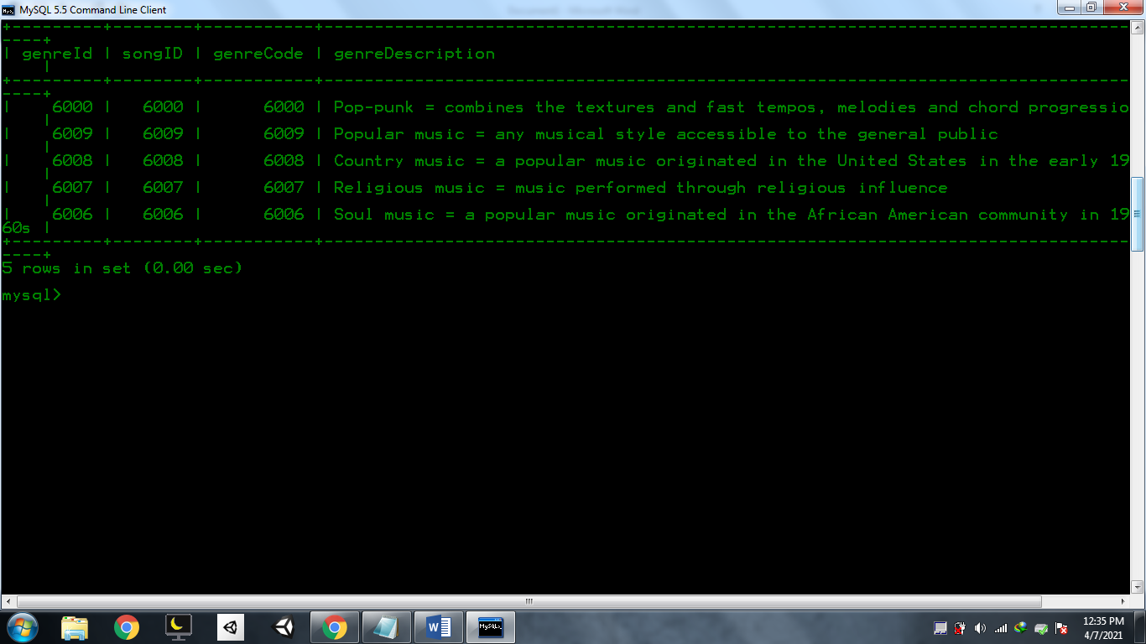

2. Joining the tables.

INNER JOIN

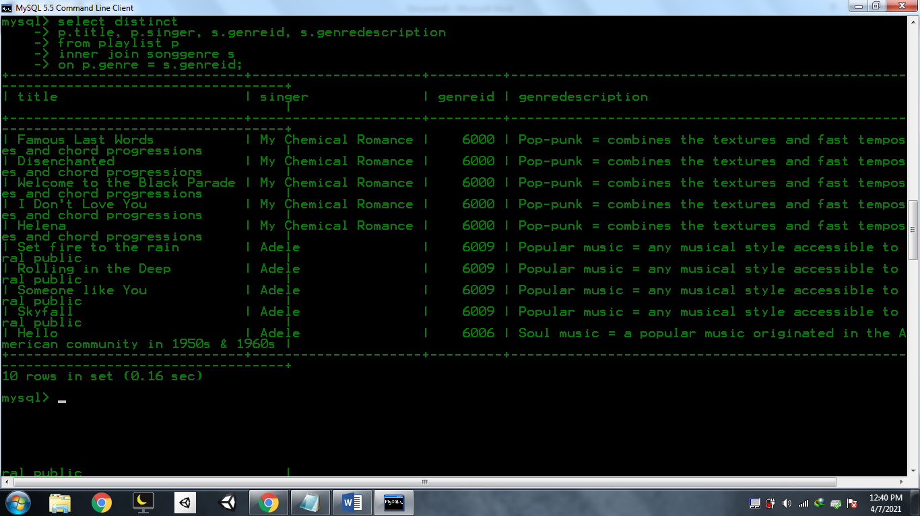

LEFT JOIN

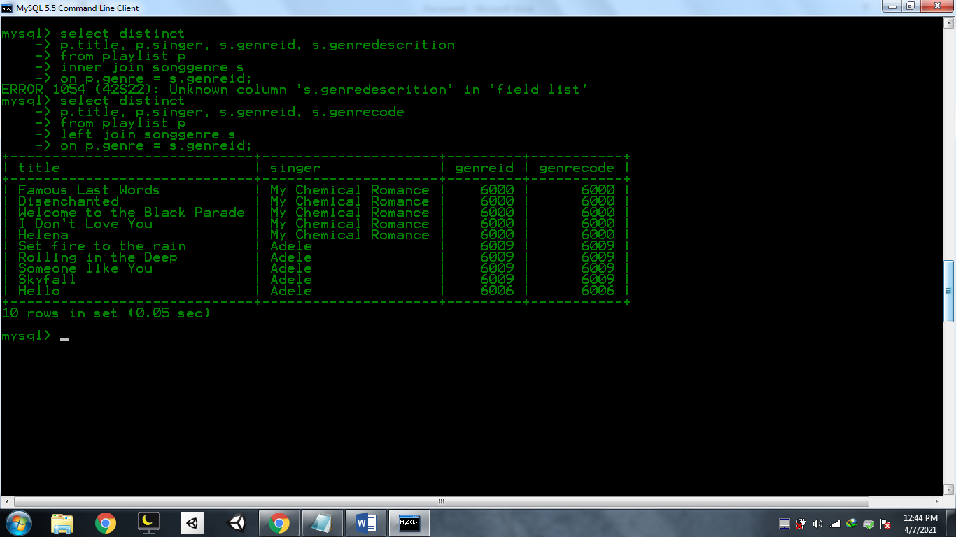

RIGHT JOIN

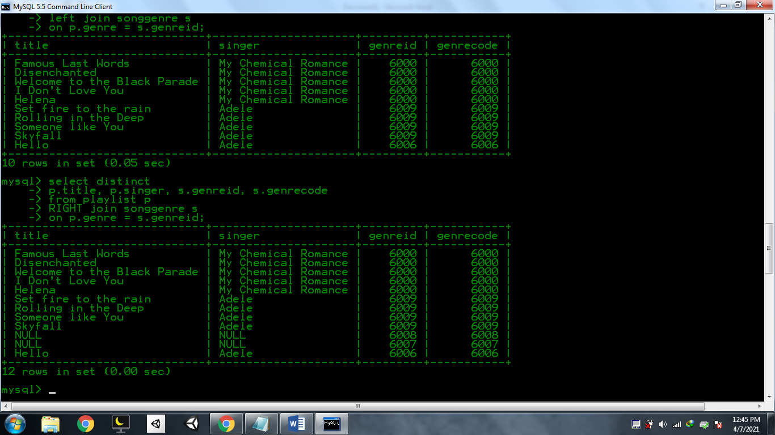

RIGHT JOIN BUT NOT NULL SINGER

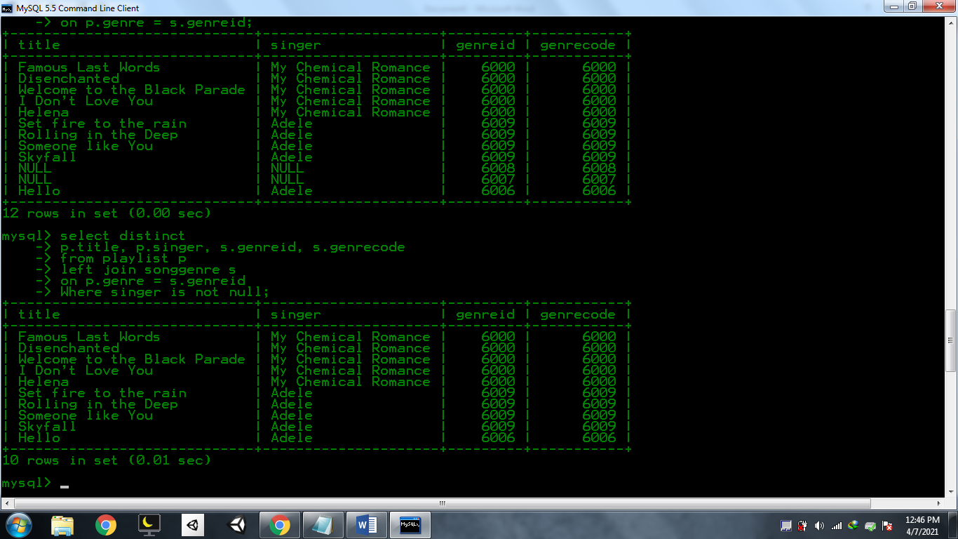

Signnificance of Joining tables:

It allows the sharing of data from one table to another. It reduces redundancies of data being inserted and created in multiple tables. Assigning them as primary keys and foreign keys are solution under the hood.